So there is one beautiful factorization technique called Matrix Factorization.

First we will learn what MF is and then we will see how it helps in Recommender systems.

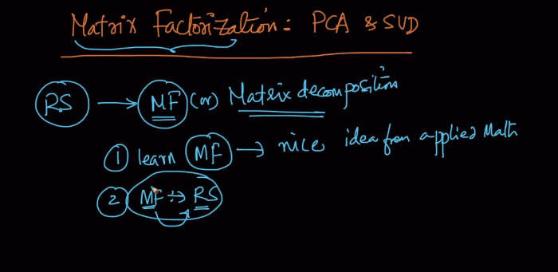

Now lets see what MF is:

So as we used to say that 2 and 3 are factors of 6 as we can write 6 as 2*3.

In the same way if A = BCD then we can say B,C,D are factors of A.

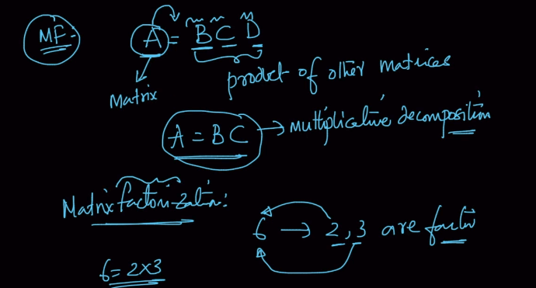

Now lets see how PCA is related MF.

So when we learnt PCA we said through our Co-variance matrix we calculate eigen-values and eigen-vectors and transformed d dimension vector to d’ dimensions using top eigen values.

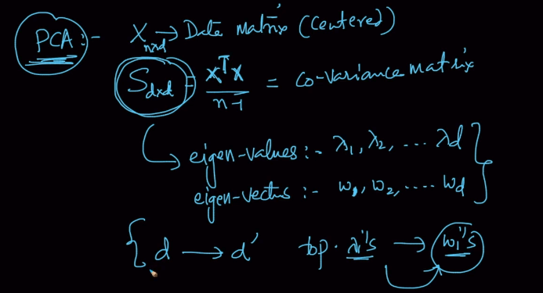

Here eigen values are represented by (lambda) and eigen vectors are represented by w.

And in below mentioned formula for calculating S(i.e. nothing but covariance matrix) W is matrix of eigen vectors. And second (cap) like term is matrix where diagonal elements are eigen values of S.

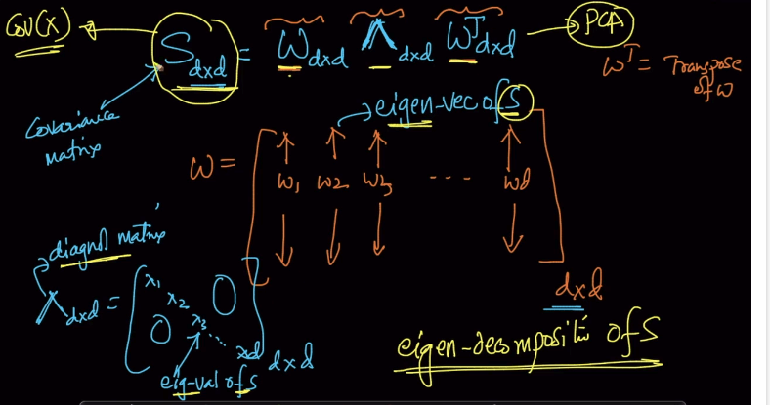

So when we understood PCA we understood it with perspective of dimensionality reduction but no its all clear that its nothing but just matrix Factorization/multiplication.

And it is also called eigen decomposition.

There is another term called SVD(Singular Value Decomposition) which is very similar to PCA.

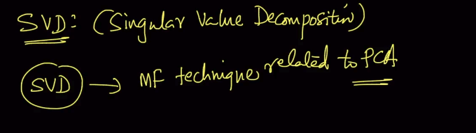

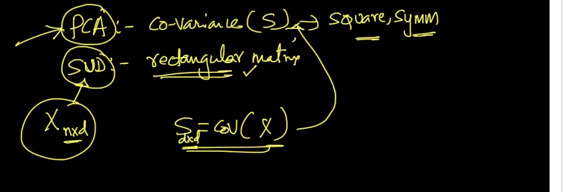

PCA can only be performed on square and symmetric matrix but SVD can be performed on any rectangular matrix. And so we can directly use X(n*d) matrix instead of calculating Cov(X).

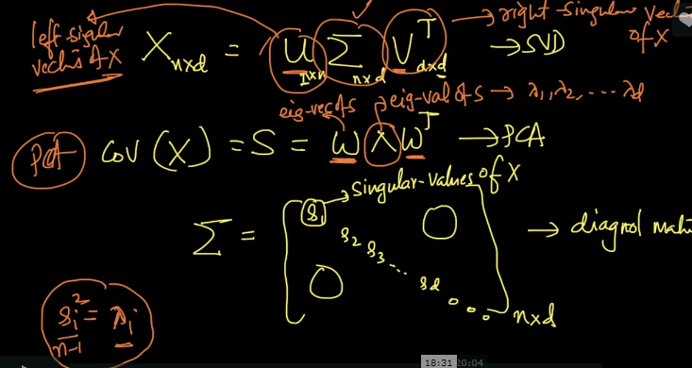

So SVD of X can be broken in above mentioned manner and Sigma here is much similar to Cap( in PCA) because as it was diagonal eigen value matrix ,similarly Sigma here is diagonal matrix of Singular value. And Singular value when squared and divided by n-1 gives us Cap

U and V here are called as Left and Right Singular values of X.

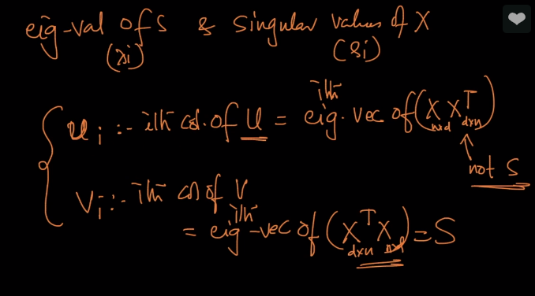

So Ui and Vi are nothing but ith eigen-vector of (XXt) and (XtX) respectively.

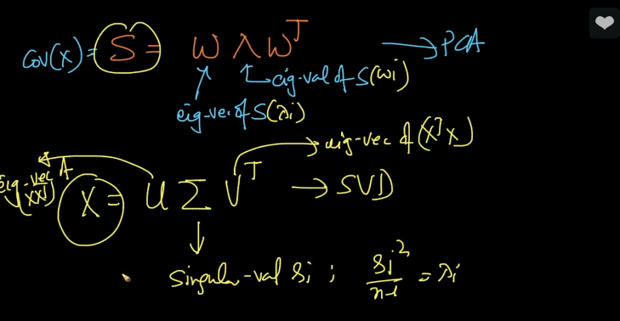

**Comments and Important Points:**

